## List Towns

You are given an **input field** with a **button**. In the input field you should enter **elements** **separated** by comma and whitespace ("**,** "). Your task is to create a simple **template** that defines a **list** of towns. Each **town** comes from the **input** field. The list should be **rendered** inside the element with Id "**root**".

### Screenshots

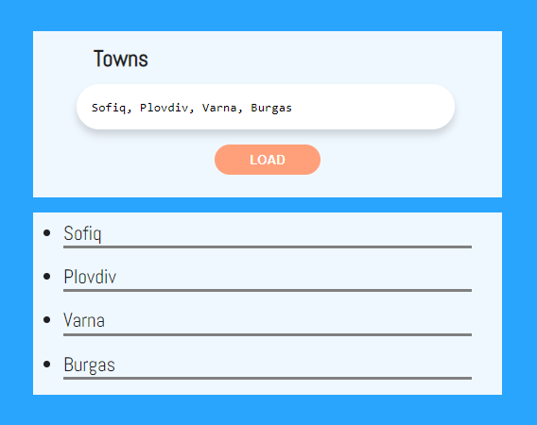

This is how the HTML should look like with the rendered template:

